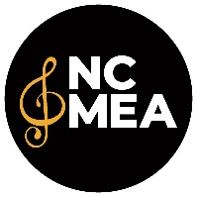
NCMEA Recording Agreement

NCMEA Sponsored Event ______________________________________________________________________

Name of Event Chair __________________________________________________________________________

Mailing Address _______________________________________________________________________________
Street City State Zip Code

E-mail Address ________________________________________________________________________________

School Phone _______________________________ Cell Phone _________________________________________

Recording Location

Site Name ____________________________________________________________________________________

Site Address__________________________________________________________________________________
Street City State Zip Code

On Site Contact _______________________________________________________________________________

Date ____________________________________________ Time _______________________________________

Other Information ______________________________________________________________________________

_____________________________________________________________________________________________

NCMEA will provide ___________________________________________________________________________

Name of Company Providing Services_____________________________________________________________

Mailing Address _______________________________________________________________________________
Street City State Zip Code

E-mail Address ________________________________________________________________________________

Business Phone _________________________________ Cell Phone _____________________________________

Name of Technician for the Recording Session _______________________________________________________

Recording Company will provide __________________________________________________________________

_____________________________________________________________________________________________
Please provide copies of all copyright paperwork for NCMEA files.

______________________________________________________ __________________________________
Signature of Company Representative Date

______________________________________________________ __________________________________
Signature of NCMEA Student Event Chair Date

