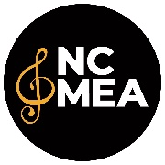
NCMEA Student Event
Certificate of Insurance Request Form

Use only if your event site requires a certificate of insurance

In order to get a Certificate of Insurance for a student event site, please provide the NCMEA Executive Director with the following information, at least two (2) weeks prior to the event, so information can be forwarded to our insurance company. Be sure you get the correct contact person and email address.

NCMEA Section
Name of event
Event chair
Date(s) of event
Time of event – Complete Schedule should be provided on a separate sheet.
Location - name of the site, church, school, university
Site address, including zip code
Building or part(s) of the building to be used
If your contract requires your site to be listed as Additional Insured, how does it need to be listed? (If this is needed, it should be in your contract; if it’s not, leave blank.)
Site contact person
Person who should receive the certificate
Email for person who should receive the certificate
Number of student participants (estimated)
Number of adult chaperones
Security will be provided by
Will food or beverage be provided?

Please provide information to the NCMEA Executive Director, preferably by email attachment.

NCMEA
Susan Heiserman, Executive Director
883-C Washington St
Raleigh, NC 27605
Phone: 919-424-7008
sheiserman@ncmea.net

