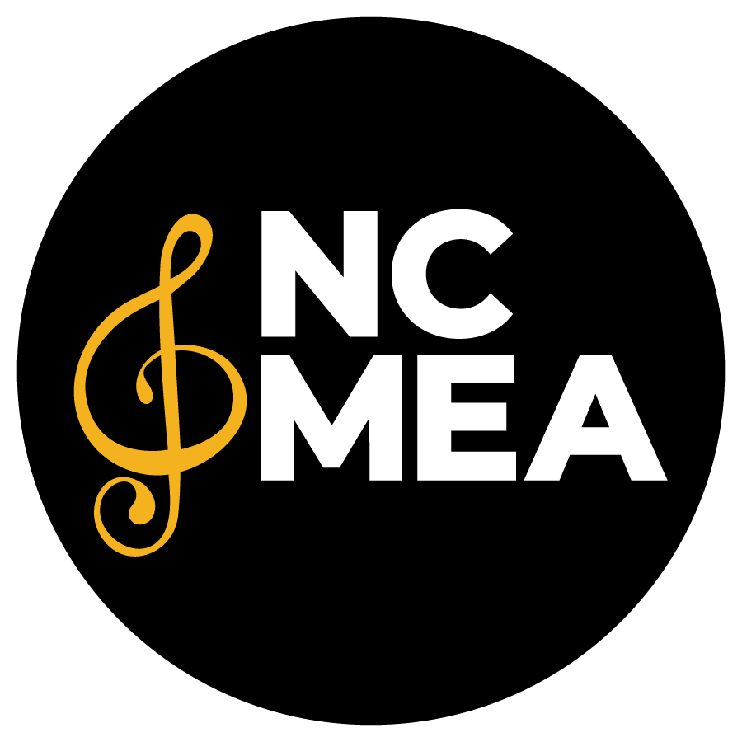
North Carolina Music Educators Association
Student Event Handbook
2023-2024

NCMEA Student Events - General Policies & Procedures 2
How to Create and Submit a Student Event Financial Report 4
Student Event Bank Account FAQ 6
Sample Reporting Forms 8

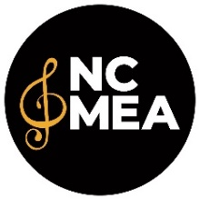
NCMEA Student Events - General Policies & Procedures
2023-2024

NCMEA Student Event Financial Reports enable the NCMEA Office to capture enough data to ensure compliance with various federal government reports which much be filed covering all activities of NCMEA. These reports must be both timely and accurate or NCMEA might be subject to penalties and/or revocation of our non-profit status. Your help in this regard is critical to our compliance with the reporting requirements.

FISCAL YEAR: The NCMEA fiscal year runs from July 1 through June 30. The NCMEA financial reports and tax returns are on based on our fiscal year. All NCMEA Section finances are reported under the NCMEA Tax ID 56-1081959.

W-9 FORMS / IRS 1099 REPORTING: NCMEA is required to report to the IRS all persons who were paid a fee totaling $600 or more in a calendar year. NCMEA will mail IRS Form 1099s by January 31.
- W-9 forms are required from everyone who receives an honorarium, including clinicians, adjudicators, accompanists, event and site chairs, treasurers, etc.
- Even if you pay someone less than $600, we need to know because they may have received other payments during the calendar year for another event.
- If you only reimburse someone’s expenses but don’t pay an honorarium, we don’t need a W-9.
- We prefer that new W-9s are submitted each year. The IRS occasionally updates the form and people’s addresses change. (Don’t assume the information we might have on file is correct.)
- Please remind everyone to write clearly (or type) on the forms so we don’t make a mistake on their 1099.
- IRS W-9 forms can be found on the NCMEA website or www.irs.gov/pub/irs-pdf/fw9.pdf.
NCMEA W-9
Many school finance offices require a vendor W-9 so they can cut checks for your event. If a music director or school finance officer asks for an NCMEA W-9, have them send an email request to the Executive Director at the NCMEA Office.

EVENT REPORTING FORMS AND POLICIES
Always use forms from the Student Event Reporting Forms page of the NCMEA website (under “Member Resources”). They should have the current fiscal year listed at the bottom. Do not save and reuse forms from year to year because they are updated occasionally.

EVENT BUDGETS
All student events held under the umbrella of NCMEA are required to provide a preliminary budget by August 31st of the fiscal year in which the events occur. The coordinator of the student event must submit the budget for approval by the governing body of the event section/district and submit to the executive director of NCMEA.

The Budget Form Worksheet can be found on the Student Event Reporting Forms webpage.

STUDENT EVENT REPORT DEADLINES
- December 15 for events between July-December
- June 15 for events between January-June

ADVOCACY & PROMOTION
In an effort to better promote NCMEA to our members and the community, please include the current NCMEA logo on your event programs and other publicity materials. Each Section has a version of the logo. You can get the logo from your Section Chair or by request from the NCMEA office. You may use the logo in color or black & white.

Thank you for your willingness to serve in a leadership role for NCMEA student events! Your service in this capacity provides important musical opportunities for the students and teachers of your section and region of NCMEA, and you provide the local face of the organization.

Please do not hesitate to contact the Executive Director should you have questions or need help via email or 919-424-7008.

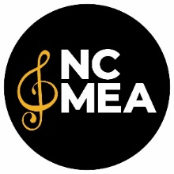
How to Create and Submit a Financial Report
2023-2024

- Access Form 101 – Student Event Financial Report from the NCMEA website (www.ncmea.net > Member Resources > Student Event Reporting Forms – available as an Excel spreadsheet. Google Sheet version is available upon request to the Executive Director. If using the Google Sheet, MAKE A COPY before filling it in.)
- Fill out the Event Info, Income, and Expense tabs. The Profit & Loss tab will auto-calculate. You only need to fill in cells highlighted in blue.
- Be sure to select the correct category from the dropdown menu on the Expense tab
- For anything reported on a Form 201, select either “201 – Honorarium” or “201 – Expense Reimbursement.” Use the remaining categories for all other expenses not reported on a Form 201.
- Use this form to track all income and expenses for your event. It’s easiest if you keep track as you go, rather than saving it and trying to remember it all after the event.

- Create a Google folder – Title it by Section, District, Event Type
(ex. "HS Choral West 1 LE MPA" or "ECDBA HS District Clinic")
- Upload or copy/paste your Form 101- Student Event Financial Report into this folder.
- Create the following subfolders and upload the corresponding files:
  - Form 200 Contracts (signed contracts for all accompanists, adjudicators, clinicians, conductors)
  - W9s (required for anyone paid an honorarium of any amount, including site and event chairs)
  - Forms 201 with receipts* (Form 201 required for any person who is paid an honorarium and/or reimbursed for expenses)
  - Expense receipts* (for all other expenses NOT included on a Form 201 – e.g. food, music, supplies, etc.).

*Copies of receipts for all event expenses are required to be submitted with your report. Please make sure they are clear and legible and, to the extent possible, that they include the business name, date, subtotal, and tax amounts. Why? NCMEA records and submits this information for sales tax refunds twice per year. Sales tax refund money is used to fund programs like scholarships and grants and advocacy activities.
- Also upload event schedules, programs, and MPA ratings as applicable.

- Once your Google folder is complete, share it with StudentEvents@ncmea.net
(Make sure the “Notify people” box is checked so we are notified when it is shared.)

*Please retain paper forms, records, and receipts for a minimum of three years.

ABOUT OTHER STUDENT EVENT FORMS

Form 100: Student Event Budget
All student events held under the umbrella of NCMEA are required to provide a preliminary budget by August 31st of the fiscal year in which the events occur. Include your best estimates for projected income and expense; it is often helpful to refer to previous years’ actual numbers. Form 100 will be available on the NCMEA website as an Excel spreadsheet or as a Google Sheet by request to the Executive Director. If using the Google Sheet, MAKE A COPY before filling it in.

Form 201: NCMEA Payment and/or Expense Reimbursement Request Form
This is used for honorarium payments or expense reimbursements to any individual, including but not limited to accompanists, clinicians, conductors, adjudicators, site chairs, event chairs, etc.
- All expenses listed on the form (except honoraria & mileage) must have receipts that are submitted to the NCMEA office with Financial Report documentation.
- Form 201 must be submitted for everyone who is paid an honorarium, including site and event chairs.
- No payment should be made that exceeds the per diem amount allowed and stated on the form.
- The Section Treasurer writes all checks for adjudicators and clinicians.
- The Section Treasurer may write checks for Event and Site Chairs once their reporting forms are submitted to the Treasurer.
- Section Treasurers and Event Chairs shouldn’t write checks to themselves. Instead, submit a Form 201 to the NCMEA office for payment. NCMEA will write the check and deduct the funds from the corresponding section/event account.
- Please include the check number, date, and amount in the box at the bottom of the form.

Form 106-107: MPA Rating Forms (three versions)
You may use the forms provided by NCMEA or a form used for your specific event.

Form 108: MPA Plaque Order Form
Please be sure you are using the most recent form as plaque prices change frequently. The current (FY 23-24) price for a MPA Superior Plaque is $100. The office will not accept out of date forms.

Form 109: Certificate of Insurance Request Form
Some event sites require a Certificate of Insurance (COI). At least two weeks prior to the event, fill out the form and email to the Executive Director. It will be forwarded to NCMEA’s insurance representative and the COI will be emailed to the contact listed on the form.

Form 110: Recording Agreement
This form should be utilized when making arrangements to have an NCMEA-sponsored event recorded. Please be sure to use this form to document any recording agreements. Copyright clearance documentation is required.

Form 200: Accompanist/Adjudicator/Conductor Agreement
This contract must be used when hiring an Accompanist, Adjudicator, Clinician, or Conductor, paying them an honorarium and reimbursing expenses. This form must also be submitted with your financial report. This form may also be used for commission works.

Student Event Bank Account FAQ
2023-2024

SECTION/DISTRICT/EVENT BANK ACCOUNTS
- NCMEA student event bank accounts are held at Truist.
- All bank accounts MUST be set-up through the NCMEA office.
  - To open a new account the NCMEA office will need a written request approved by the NCMEA section board.
- The NCMEA Executive Director will be the main signature on ALL NCMEA bank accounts. Section Treasurers and Section Chairs may be signers on the section checking account.
- NCMEA has a team at Truist that services our bank accounts. All requests for new checks, deposit slips and credit cards MUST come through the NCMEA office. DO NOT go visit your local branch, as they won’t be able to help you.
- Account signers will be given access to view their accounts online; please contact the Executive Director for login assistance when needed.

CHECKS
- Each account will have checks issued. New checks must be requested through the NCMEA office. Advance notice is needed because it often takes a few weeks for the bank to process orders.
- Lost, stolen or compromised checks MUST be reported to the NCMEA office immediately.
- Checks should only be used to pay people for honorariums or reimbursements. (Use the credit card for all other purchases.)
- Section Treasurers or Event Chairs shouldn’t write checks to themselves; instead submit a Form 201 to the NCMEA office for payment.

CREDIT CARDS
- Most student events have their own credit card. The credit cards are all under an NCMEA corporate account, so the billing address is the NCMEA office: 883 Washington St., Ste. C, Raleigh, NC 27605.
- It is best practice to use the credit card for ALL purchases. Checks should only be used to pay people for honorariums or reimbursements.
- Lost, stolen, or compromised cards MUST be reported to the NCMEA office immediately.
- The NCMEA office can increase and decrease your credit card limit. Limits can be increased to cover expenses needed for your event. Otherwise, credit card limits will be kept at $500 or less. Inform the Executive Director of an estimate of expenses that will be needed for your event in advance.
- You do not need to pay your own credit card bill; NCMEA receives one master bill around the 5th of each month and pays all balances from your section or event checking accounts.
- During leadership transitions, credit cards can be transferred from one section or event chair to the next; new cards are not required.

DEPOSITS
- Checks for student events should be made out to NCMEA and may include the sub-name on your account (either on the Pay To line or Memo line). For example: NCMEA CDBA | NCMEA HS HONORS CHORUS
- All deposits should be made with the deposit slip provided with the account.
- Event Chairs/Treasurers should deposit checks weekly. DO NOT hold checks more than 30 days. If this instruction cannot be followed, we may require your event checks be mailed to the NCMEA office for deposit.
- Be sure to keep checks in a locked, secure place.

Sample Reporting Forms
